**Shootings In New York City**

*Luis Cerrilla, Arthur Edwards, Ahasan Hossain and Kyle Cielencki*

Every day, it is estimated that more than 100 Americans are killed with guns and 200 more are shot and wounded1. Gun violence shapes the lives of Americans as it has become a part of everyday American life. 75% of the world's 875,000,000 guns are civilian controlled, with ~48% of these guns in the United States, which has the highest rate of gun ownership in the world2. For the past decade, New York City embraced the title of the “safest big city in the country,” as it noticed a relative decline in gun violence. Our team analyzed every reported shooting over the last eight years in New York City.

New York City is divided in five boroughs: Brooklyn, Queens, Manhattan and Staten Island. Which of these boroughs is the safest in terms of gun violence? Which age group is affected by gun violence the most? Is there a seasonality for gun violence in New York? These are all questions our team answered in the below.

**Overview of the Data**:

The data our team analyzed is from the City of New York Open Data (“Open Data”) 3, a partnership between the Mayor’s Office of Data Analytics (MODA) and the Department of Information Technology and Telecommunications (DoITT). The data is an aggregation of every shooting incident that occurred in New York City going back to 2006 through the end of the previous calendar year.

The original City of New York data is manually extracted every quarter and reviewed by the Office of Management Analysis and Planning before being posted on the NYPD website. Each record represents an actual *reported* shooting incident in New York City and includes information about the event, the location and time of occurrence. Additionally, the information related to suspect and victim demographics is also included. It should be noted that we analyzed reported shootings, this does not encompass all shooting incidents occurring in New York City.

**Shootings by Boro**:

The Boro of Brooklyn has the majority of shootings for each of the years analyzed (2006-2018):

**2006** **2018**

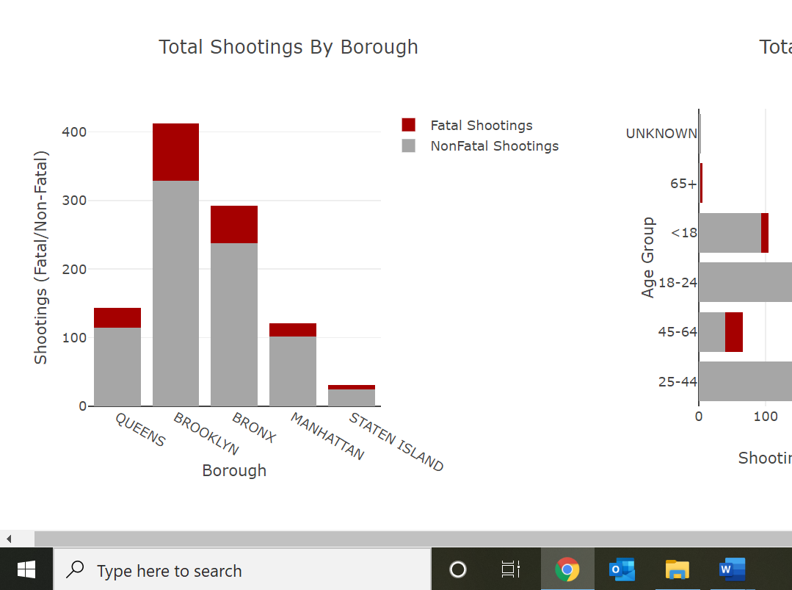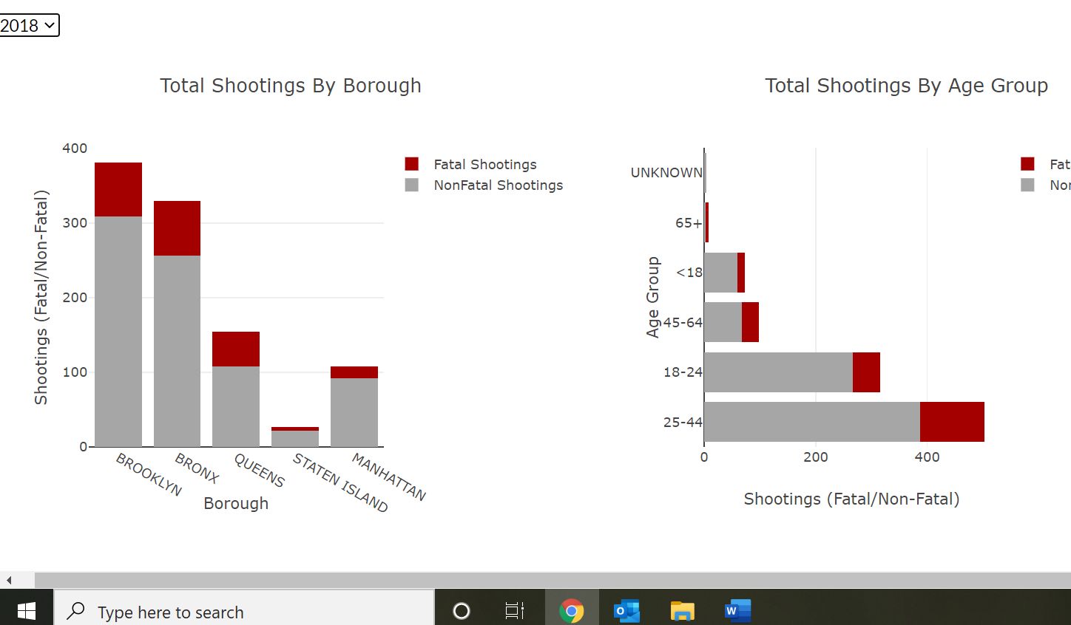

This is followed by The Bronx, with Staten Island deemed the “safest” Boro in terms of gun violence. This could be largely due to Staten Island having the lowest population of the five Boros. More so, we noticed gun violence was largely divided along neighborhood lines. In Brooklyn, we noticed a higher concentration of shootings in Crown Heights, East Flatbush and Bed-Stuy. Neighborhoods such as Brooklyn Heights (a very affluent neighborhood) and Red Hook (a sparsely-populated neighborhood) contributed little-to-none of the shooting incidents. This also holds true for Queens with Jamaica hosting the highest number of shooting incidents in the Boro. For Manhattan, shootings followed the clear neighborhood dividing lines:

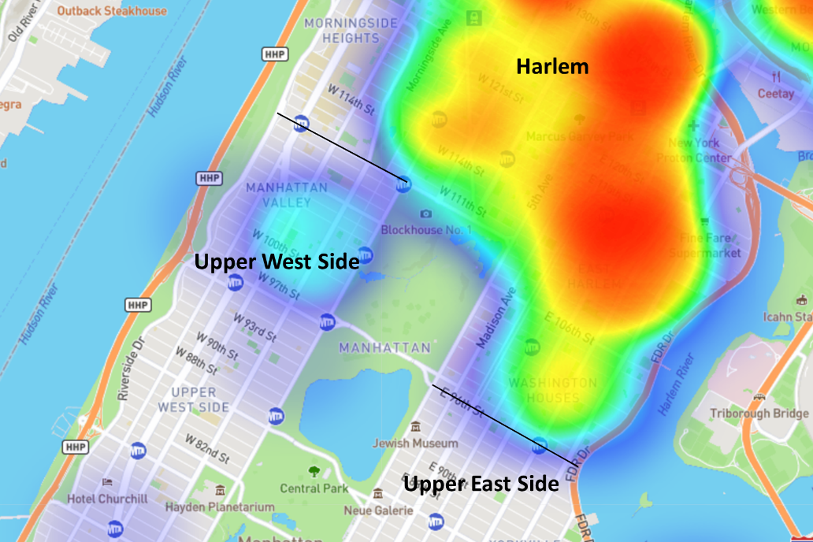

**Seasonality**:

New York State is located in the Northeastern United State along the Atlantic Coast part of the USA. This area is known for cold winter seasons accompanied by ample snowfall. Therefore, the colder months tend to exhibit a decrease in shooting incidents with the warmer months (July and August in particular) noting increases in gun violence.

**2018 Monthly Breakout**

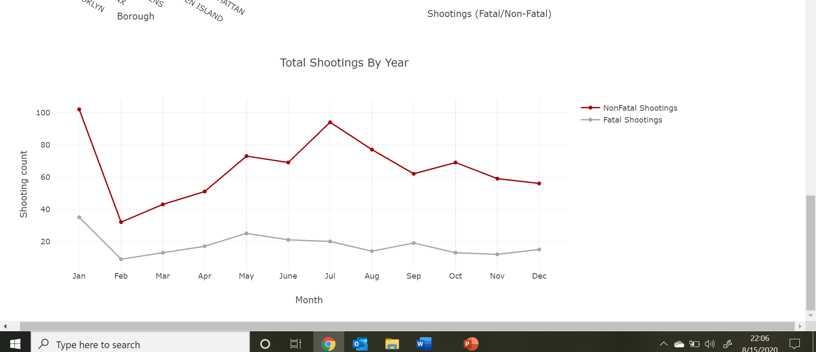

This is consistent with general trends across the United States as people tend to be outside more, school is out of session and daylight hours are longer in the summer months. It is also postulated that heat-induced discomfort simply makes people more aggressive and likely to act out. However, January has noted increased shootings (sometimes even the highest number of shootings). This might be attributed to other reasons and warrants further research.

**Age Demographics**:

We analyzed the age demographics of the victims involved in shooting incidents. One of our findings was that most victims are on an age group between 25 and 44 years old:

**2006** **2008**

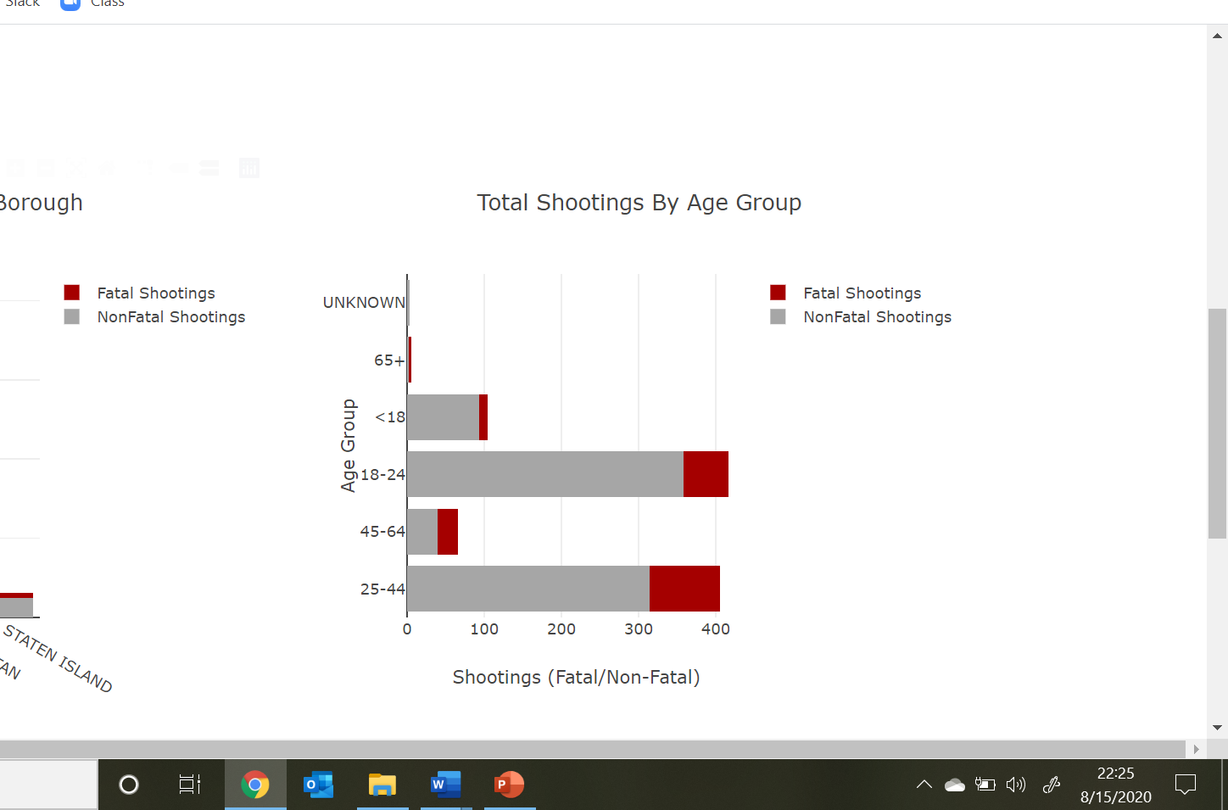 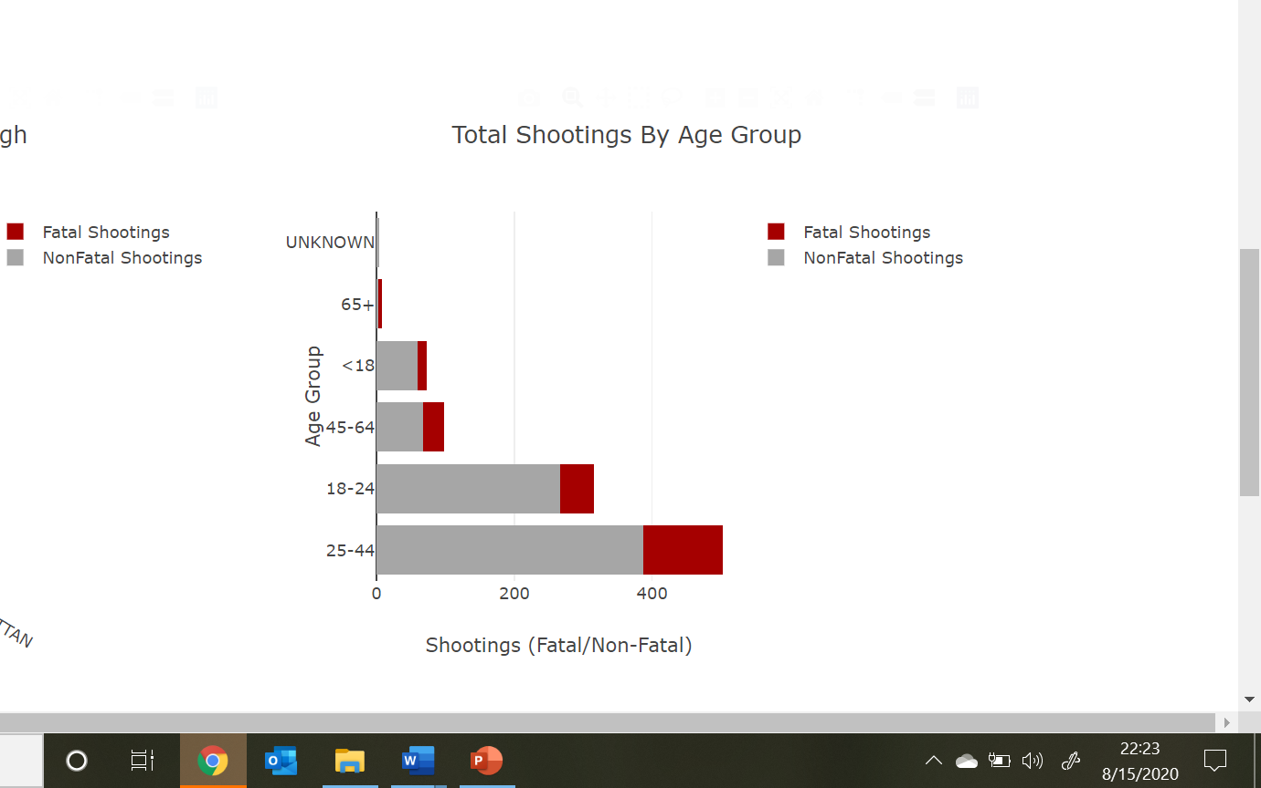

This was closely followed by the 18-24 years old age group. While it might be incurred that people younger than 44 are involved in shootings, it is more likely that the younger half of this age group contributes more to these statistics. This presented us with one of our first issues when analyzing the data: age groups were already defined in the Open Data. The age groups were not equally-distributed, which could lead to this age group having so many shooting incidents.

**Key Takeaways**:

* Shootings increase during the summer months (June-August)
  + Additionally, there is a notable increase in January shootings.
* Shootings are mostly concentrated in Brooklyn and the Bronx
  + In other Boros, shootings follow distinct neighborhood lines.
* The 23-44 & 18-24 old age groups have the highest proportion of shootings.
  + While 23-44 years old is a large age range, further splicing of the data (more than the API currently allows) would be needed.

**Footnotes**:

1. Everytown Research & Policy (<https://everytownresearch.org/report/gun-violence-in-america/>)
2. GunPolicy.org (<https://www.gunpolicy.org/firearms/region>)
3. City of New York Open Data (<https://data.cityofnewyork.us/Public-Safety/NYPD-Shooting-Incident-Data-Historic-/833y-fsy8>)